**EXPERIMENT NUMBER –10**

**Student Name: Shinde Smita Shahaji UID: 20BCS4643**

**Branch: CSE (IOT) Section/Group: IOT (Group-B)**

**Semester: 2nd semester Date of Performance:05/06/2021**

**Subject Name: Quantum and Semiconductor physics lab**

AIM OF THE EXPERIMENT –

To calculate change in frequency of sound emitted by source moving relative to observer using Doppler Effect or to verify Doppler effect.

APPARATUS-

|  |  |  |
| --- | --- | --- |
| Sr.No. | Equipment | Quantity |
| 1. | Source | 1 |
| 2. | Detector / | 1 |
|  | Observer | 1 |

Diagram

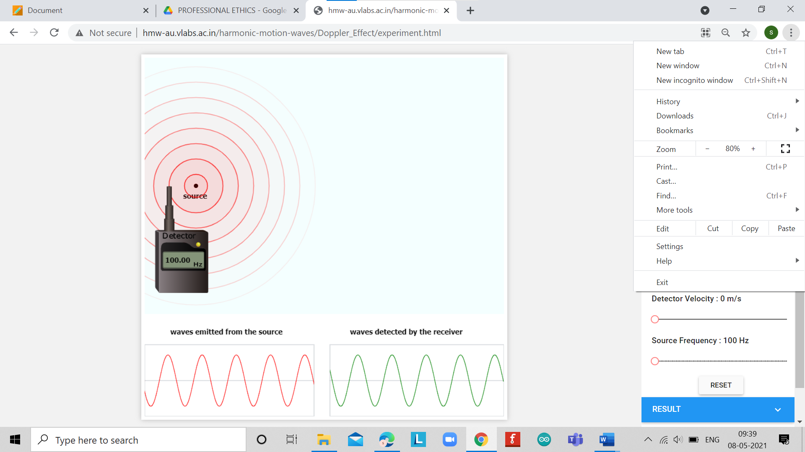

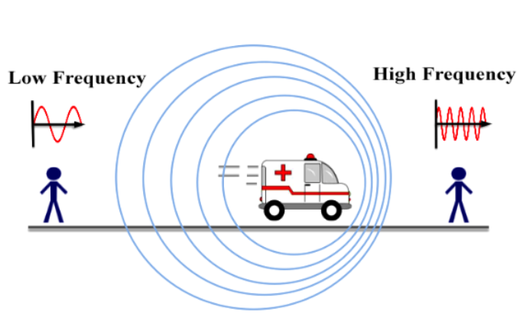

Formula used

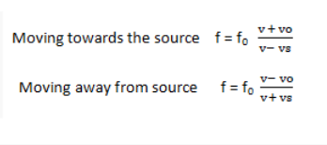

OBSERVATIONS-

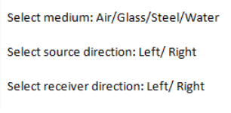

|  |  |  |  |  |  |
| --- | --- | --- | --- | --- | --- |
| **Sr.NO** | **Direction** | **Source Velocity(Vs) m/sec** | **Detector Velocity(VS) m/sec** | **Source Frequency (f0)Hz** | **Detected Frequency(f)Hz** |
| **1.** | **Towards the Source** | **200** | **150** | **100** | **344.76** |
| **2.** | **Always from the Source** | **200** | **150** | **100** | **35.54** |

Simulation results

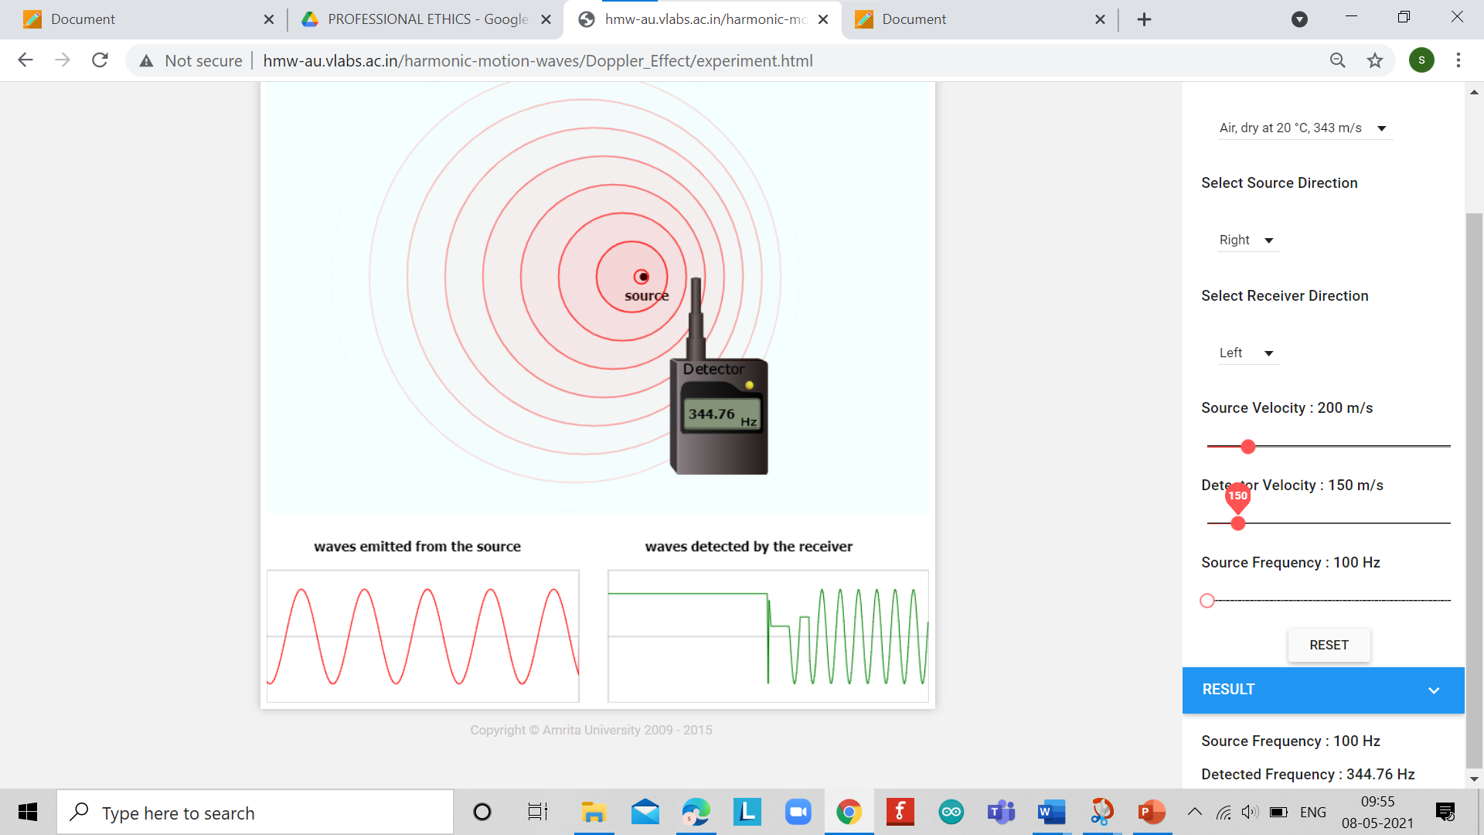

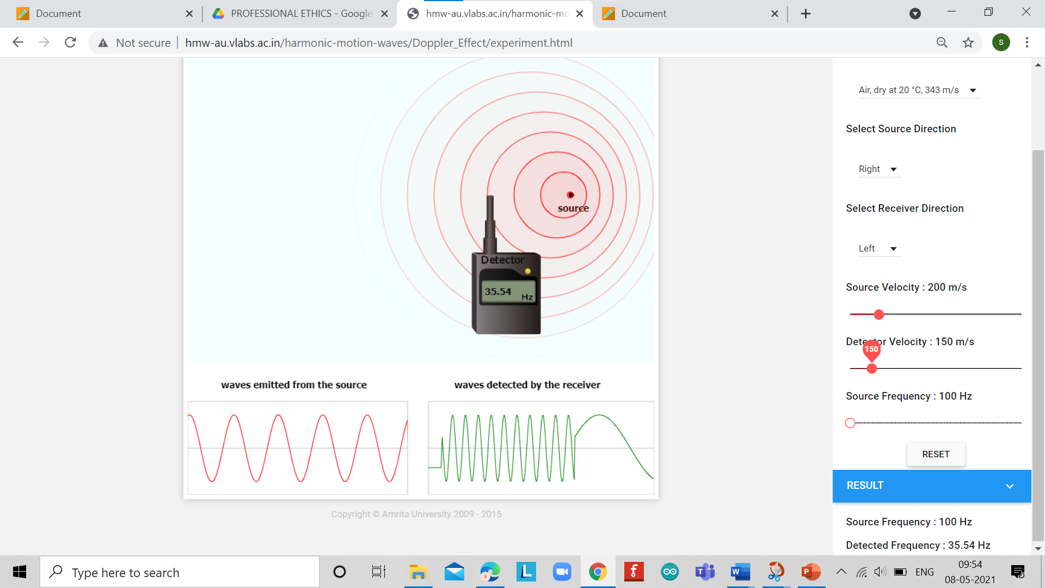

CALCULATIONS-

CALCULATIONS-

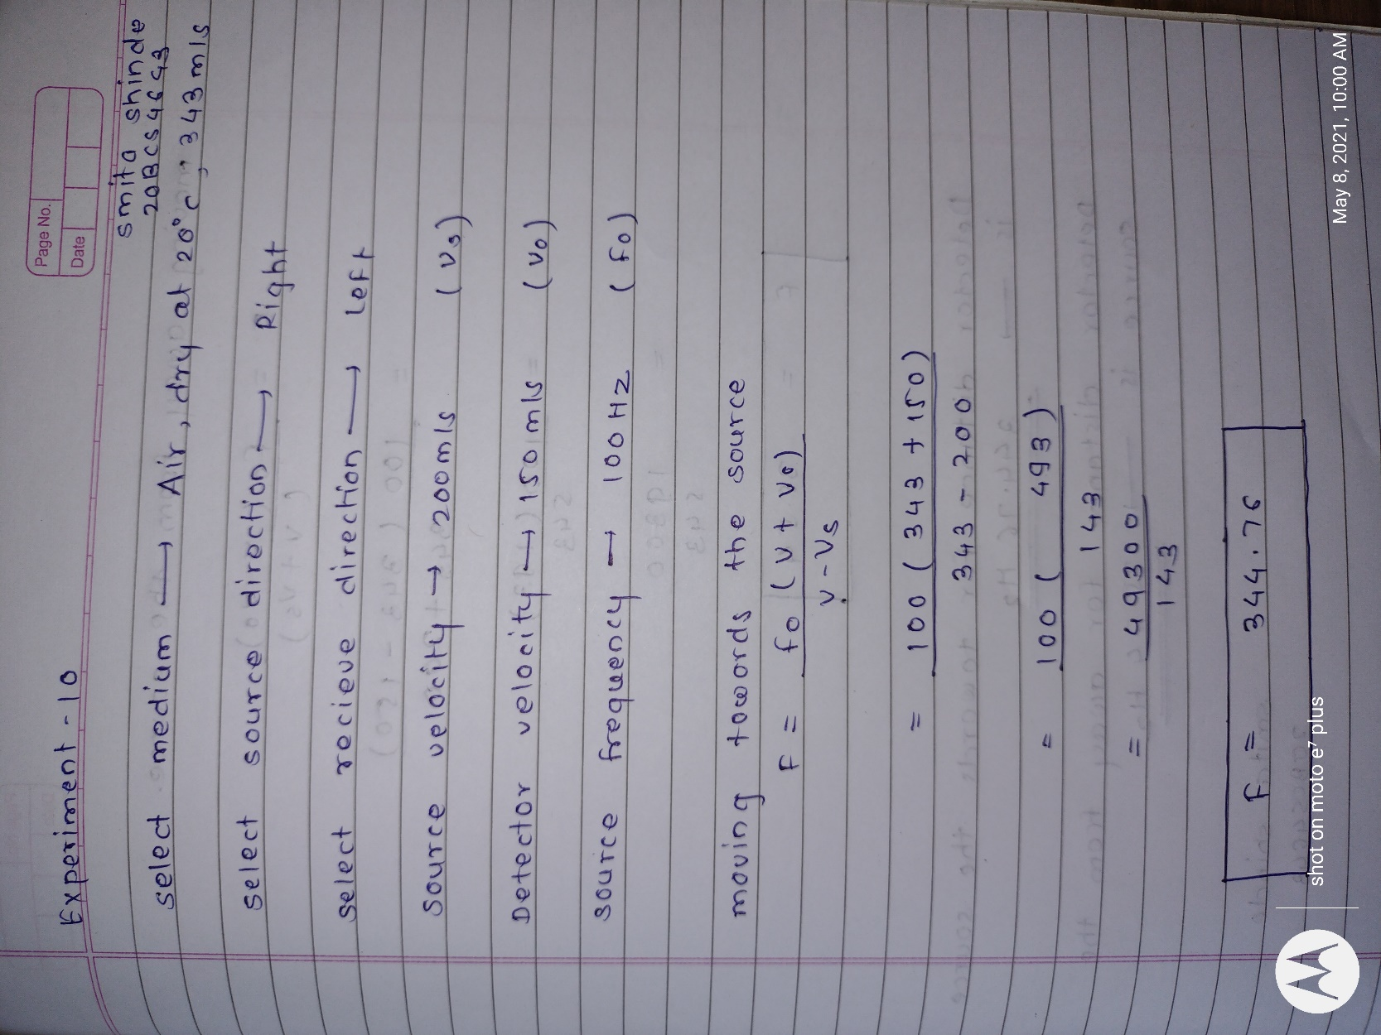

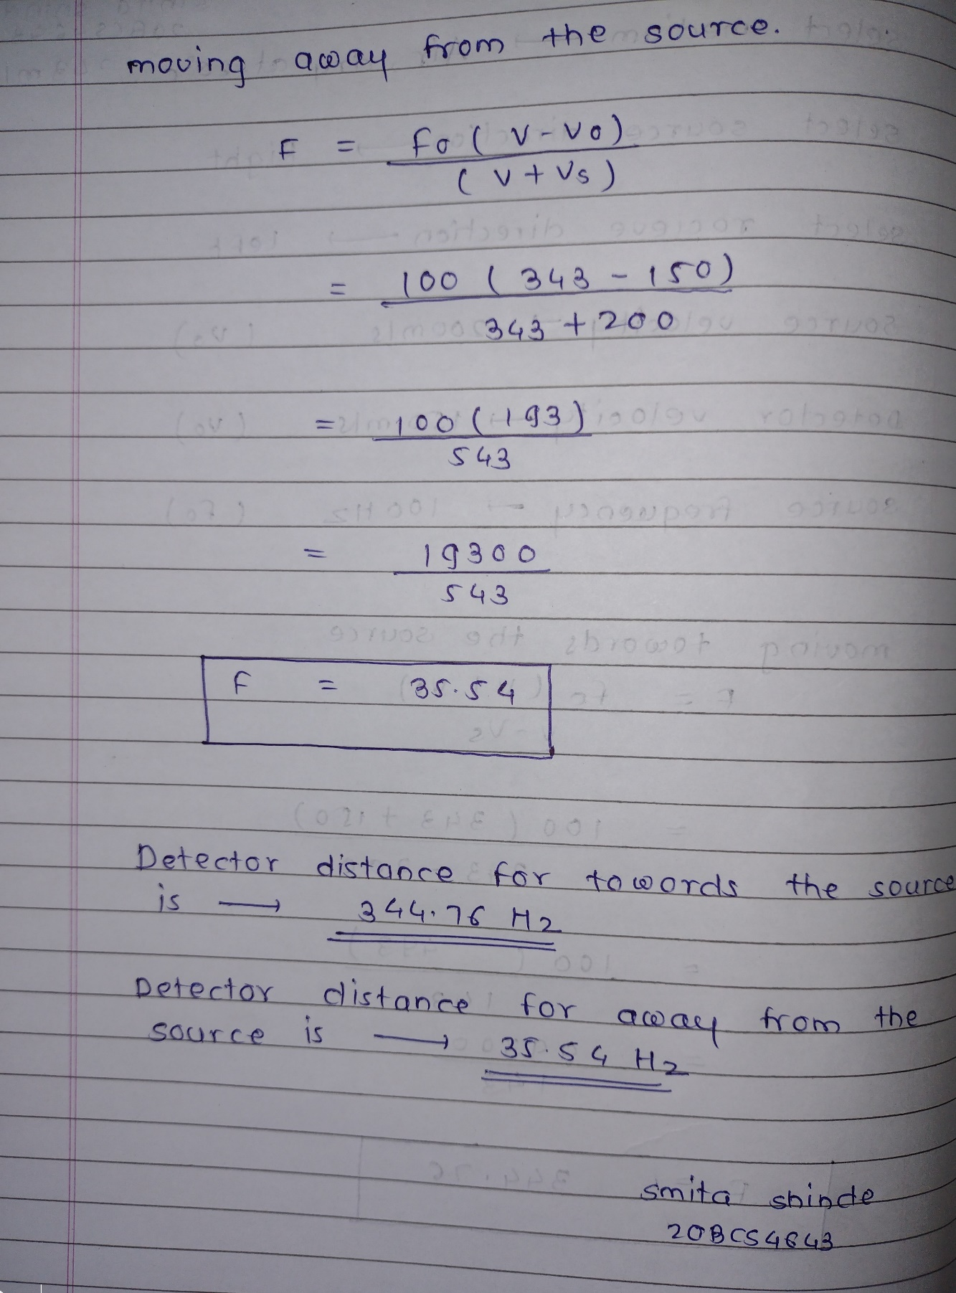

PERCENTAGE ERROR-

No any percentage error

GRAPH (ATTACH IF ANY)-

No any graph

SOURCES OF ERROR-

No any sources error

RESULTS AND DISCUSSION-

Detected frequency f (Hz)

1. Moving towards the source   f = 344.76 Hz
2. Moving away from source      f = 35.54Hz

LEARNING OUTCOMES

|  |
| --- |
| * It will provide the modest experience that allows students to develop and improve their experimental skills and develop ability to analyze data. |
| * Ability to demonstrate the practical skill on measurements and instrumentation techniques of some Physics experiments. Students will develop the ability to use appropriate physical concepts to obtain quantitative solutions to problems in physics. |
| * Students will demonstrate basic experimental skills by setting up laboratory equipment safely and efficiently, plan and carry out experimental procedures, and report verbally and in written language the results of the experiment. |
| * Students will develop skills by the practice of setting up and conducting an experiment with due regards to minimizing   measurement error. |

EVALUATION COLUMN (To be filled by concerned faculty only)

|  |  |  |  |
| --- | --- | --- | --- |
| **Sr. No.** | **Parameters** | **Maximum Marks** | **Marks Obtained** |
| 1. | Worksheet completion including writing learning objectives/Outcomes. (To be submitted at the end of the day) | 10 |  |
| 2. | Post Lab Quiz Result. | 5 |  |
| 3. | Student Engagement in Simulation/Demonstration/Performance and Controls/Pre-Lab Questions. | 5 |  |
| 4. | Total Marks | 20 |  |
| 5. | Teacher’s Signature (with date) |  | |